SCHOOL NAME Semester 2 Examination 2012
MATHEMATICS Question/Answer Booklet
3C/3D
Section One:
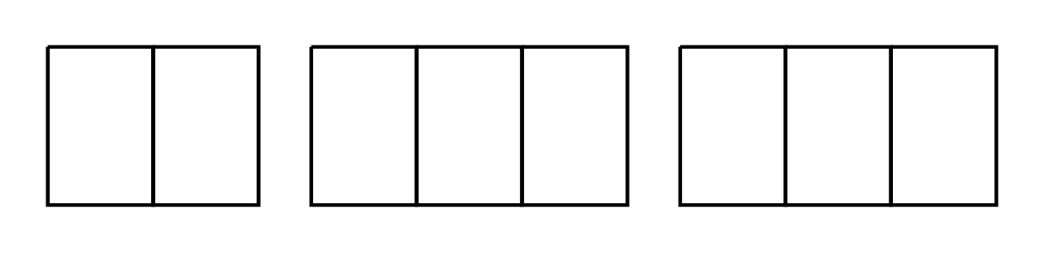Calculator-free

Student Number: In figures

In words _____________SOLUTIONS___________
____________________________________
Time allowed for this section
Reading time before commencing work: five minutes
Working time for this section: fifty minutes
Materials required/recommended for this section
To be provided by the supervisor
This Question/Answer Booklet
Formula Sheet

To be provided by the candidate
Standard items: pens, pencils, pencil sharpener, eraser, correction fluid/tape, ruler, highlighters

Special items: nil

Important note to candidates
No other items may be used in this section of the examination. It is your responsibility to ensure that you do not have any unauthorised notes or other items of a non-personal nature in the examination room. If you have any unauthorised material with you, hand it to the supervisor before reading any further.

Structure of this paper
Section | Number of questions available | Number of questions to be attempted | Working time (minutes) | Marks available | Percentage of exam
Section One:  Calculator-free | 7 | 7 | 50 | 50
Section Two:  Calculator-assumed |  |  | 100 | 100
 |  |  |  |  | 100

Question number | Marks allocated | Marks awarded
1 | 7
2 | 7
3 | 5
4 | 8
5 | 8
6 | 6
7 | 9

Instructions to candidates
- Write your answers in the spaces provided in this Question/Answer Booklet. Spare pages are included at the end of this booklet. They can be used for planning your responses and/or as additional space if required to continue an answer.
- Planning: if you use the spare pages for planning, indicate this clearly at the top of the page.
- Continuing an answer: If you need to use the space to continue an answer, indicate in the original answer space where the answer is continued i.e give the page number. Fill in the number of the question(s) that you are continuing to answer at the top of the page.
2. Show all your working clearly. Your working should be in sufficient detail to allow your answer to be checked readily and for marks to be awarded for reasoning. Incorrect answers given without supporting reasoning cannot be allocated any marks. For any question or part question worth more than two marks, valid working or justification is required to receive full marks. If you repeat an answer to any question, ensure that you cancel the answer you do not wish to have marked.
3. It is recommended that you do not use pencil, except in diagrams.

Question 1 (7 marks)

Differentiate the following with respect to x, without simplifying.

(a) $f\left(x\right)= \frac{x^{2}+1}{e^{x}}$ (2 marks)

$f^{'}\left(x\right)= \frac{2x e^{x}- e^{x}\left(x^{2}+1\right) }{e^{2x} }$

(b) $g\left(x\right)={(\left(x^{2}-3\right)\left(x^{2}+2x+5\right))}^{3}$ (3 marks)

$$g^{'}(x)=3{\left(\left(x^{2}-3\right)\left(x^{2}+2x+5\right)\right)}^{2}(2x\left(x^{2}+2x+5\right)+\left(2x+2\right)\left(x^{2}-3\right))$$

- correct use of chain rule
- correct use of product rule for brackets

or $g\left(x\right)={\left(x^{2}-3\right)}^{3}{\left(x^{2}+2x+5\right)}^{3}$

so $g^{'}(x)=6x{\left(x^{2}-3\right)}^{2}{\left(x^{2}+2x+5\right)}^{3}+3(2x+2) {\left(x^{2}+2x+5\right)}^{2}{\left(x^{2}-3\right)}^{3}$

(c) $y= \int_{1}^{4x+1}{\left(3t^{2}-2t\right)dt}$ (2 marks)

Deriv of $(4x+1)$ - replace t with$(4x+1)$
$y^{'}=4 (3{\left(4x+1\right)}^{2}-2(4x+1)$
Question 2 (7 marks)
Consider the functions $f\left(x\right)= \sqrt{x-1}$ and $g\left(x\right)= \frac{1}{x-1}$.
(a) State the natural domain and range for each function. (2 marks)
$f\left(x\right)$ Domain $\{x∈R:x≥1 \}$ Range $\{y∈R:y≥0\}$
$g\left(x\right)$ Domain $\{x∈R:x≠1 \}$ Range $\{y∈R:y≠0\}$

(b) Explain clearly why the domain for $f\left(x\right)$ has to be restricted if the function
$g ∘f(x)$ is to be a function. (1 mark)

$f\left(2\right)=1$ but $g\left(1\right)$ does not exist. So the domain of $f\left(x\right)$ must be restricted so that x cannot equal 2.

(c) Determine the equation of the function $g ∘f(x)$. State the domain and corresponding range of this function. (4 marks)

$g ∘f\left(x\right)= \frac{1}{f\left(x\right)-1}$

$= \frac{1}{\sqrt{x-1}-1}$

Domain of $g ∘f\left(x\right)=\{x∈R:1≤x<2 ∪ x>2\}$

Range of $g ∘f\left(x\right)=\{y∈R:y≤-1 ∪y>0 \}$
Question 3 (5 marks)

The diagram below shows two circles, each of radius x. Lines AD and BF are tangential to both circles as shown. The line joining the centres of the two circles, GC, bisects both ∠AEF and ∠BED.

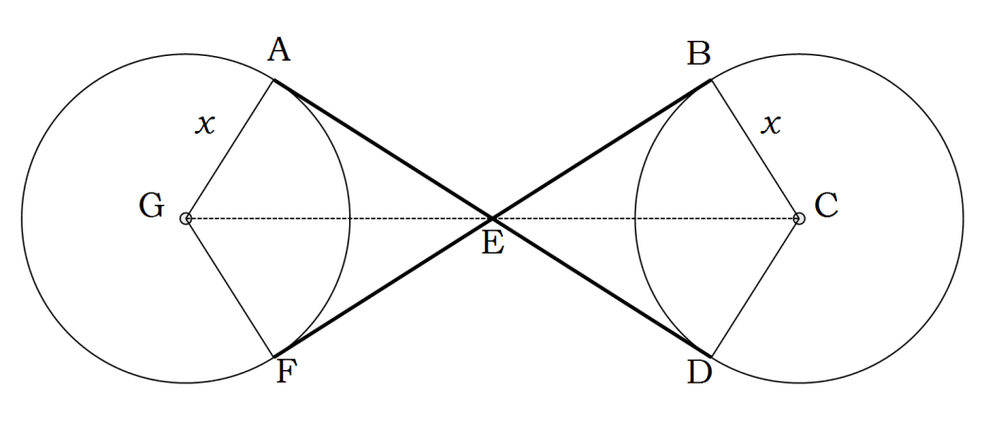
(a) Show that $∆AGE ≅∆BCE$. (3 marks)

$AG ≅BC$ (both radii of congruent circles, as given)

$GAE ≅CBE$ (EB and EA are tangents so both angles are $90°$)

$AEG ≅BEC$ ( bisected vertically opposite angles)

$∴∆AEG ≅∆BEC$ (AAS) reasoning

(b) If AE = 2x, determine, in terms of x, an expression for the exact distance between the centres of the two circles GC. (2 marks)
$GE= \sqrt{x^{2}+{(2x)}^{2}}$
$= \sqrt{5x^{2}}$
$$=\sqrt{5} x$$
$GC=2GE=2\sqrt{5} x$

Question 4 (8 marks)

(a) The table below shows the probability distribution for a discrete random variable X.
x | 1 | 2 | 3 | 4 | 5
P(X $=x$) | 2k | 3k – 0.2 | k | 0.3 – k | 0.15
 | 0.3 | 0.25 | 0.15 | 0.15 | 0.15

Determine:

- The value of k. (2 marks)

$$2k+3k-0.2+k+0.3-k+0.15=1$$

$5k+0.25=1$

$5k=0.75$

$k=0.15$

- $P ( 1<X ≤3)$ (1 mark)

$P\left(2\right)+P\left(3\right)=0.25+0.15=0.4$

- $P \left(X=2 | 1<X ≤3\right)$ (1 mark)

$\frac{0.25}{0.4}= \frac{5}{8}$

(b) Determine the value of k that makes the following function a PDF of a
continuous uniform random variable:
$f\left(x\right)=\left\{\begin{aligned}0.05 4≤x≤k \\ 0 for all other values of x\end{aligned}\right.$ (2 marks)

$$0.05 ×\left(k-4\right)=1$$

$$k-4=1÷0.05$$

$k=20+4=24$

(c) Show using integration that the following function CANNOT be a probability function of a continuous random variable:

$f\left(x\right)=\left\{\begin{aligned}\frac{x}{15} 0≤x≤4 \\ 0 for all other values of x\end{aligned}\right.$ (2 marks)

$\int_{0}^{4}{\frac{x}{15} dx}$
$=[{\frac{x^{2}}{30} ]}_{0}^{4}$
$\frac{4^{2}}{30}-0= \frac{16}{30}$
Since the integral $≠1$ over the domain of the function, it cannot be a PDF

Question 5 (6 marks)

In the graph below, area A = 14 units, area B = 2 units, area C = 1 unit,
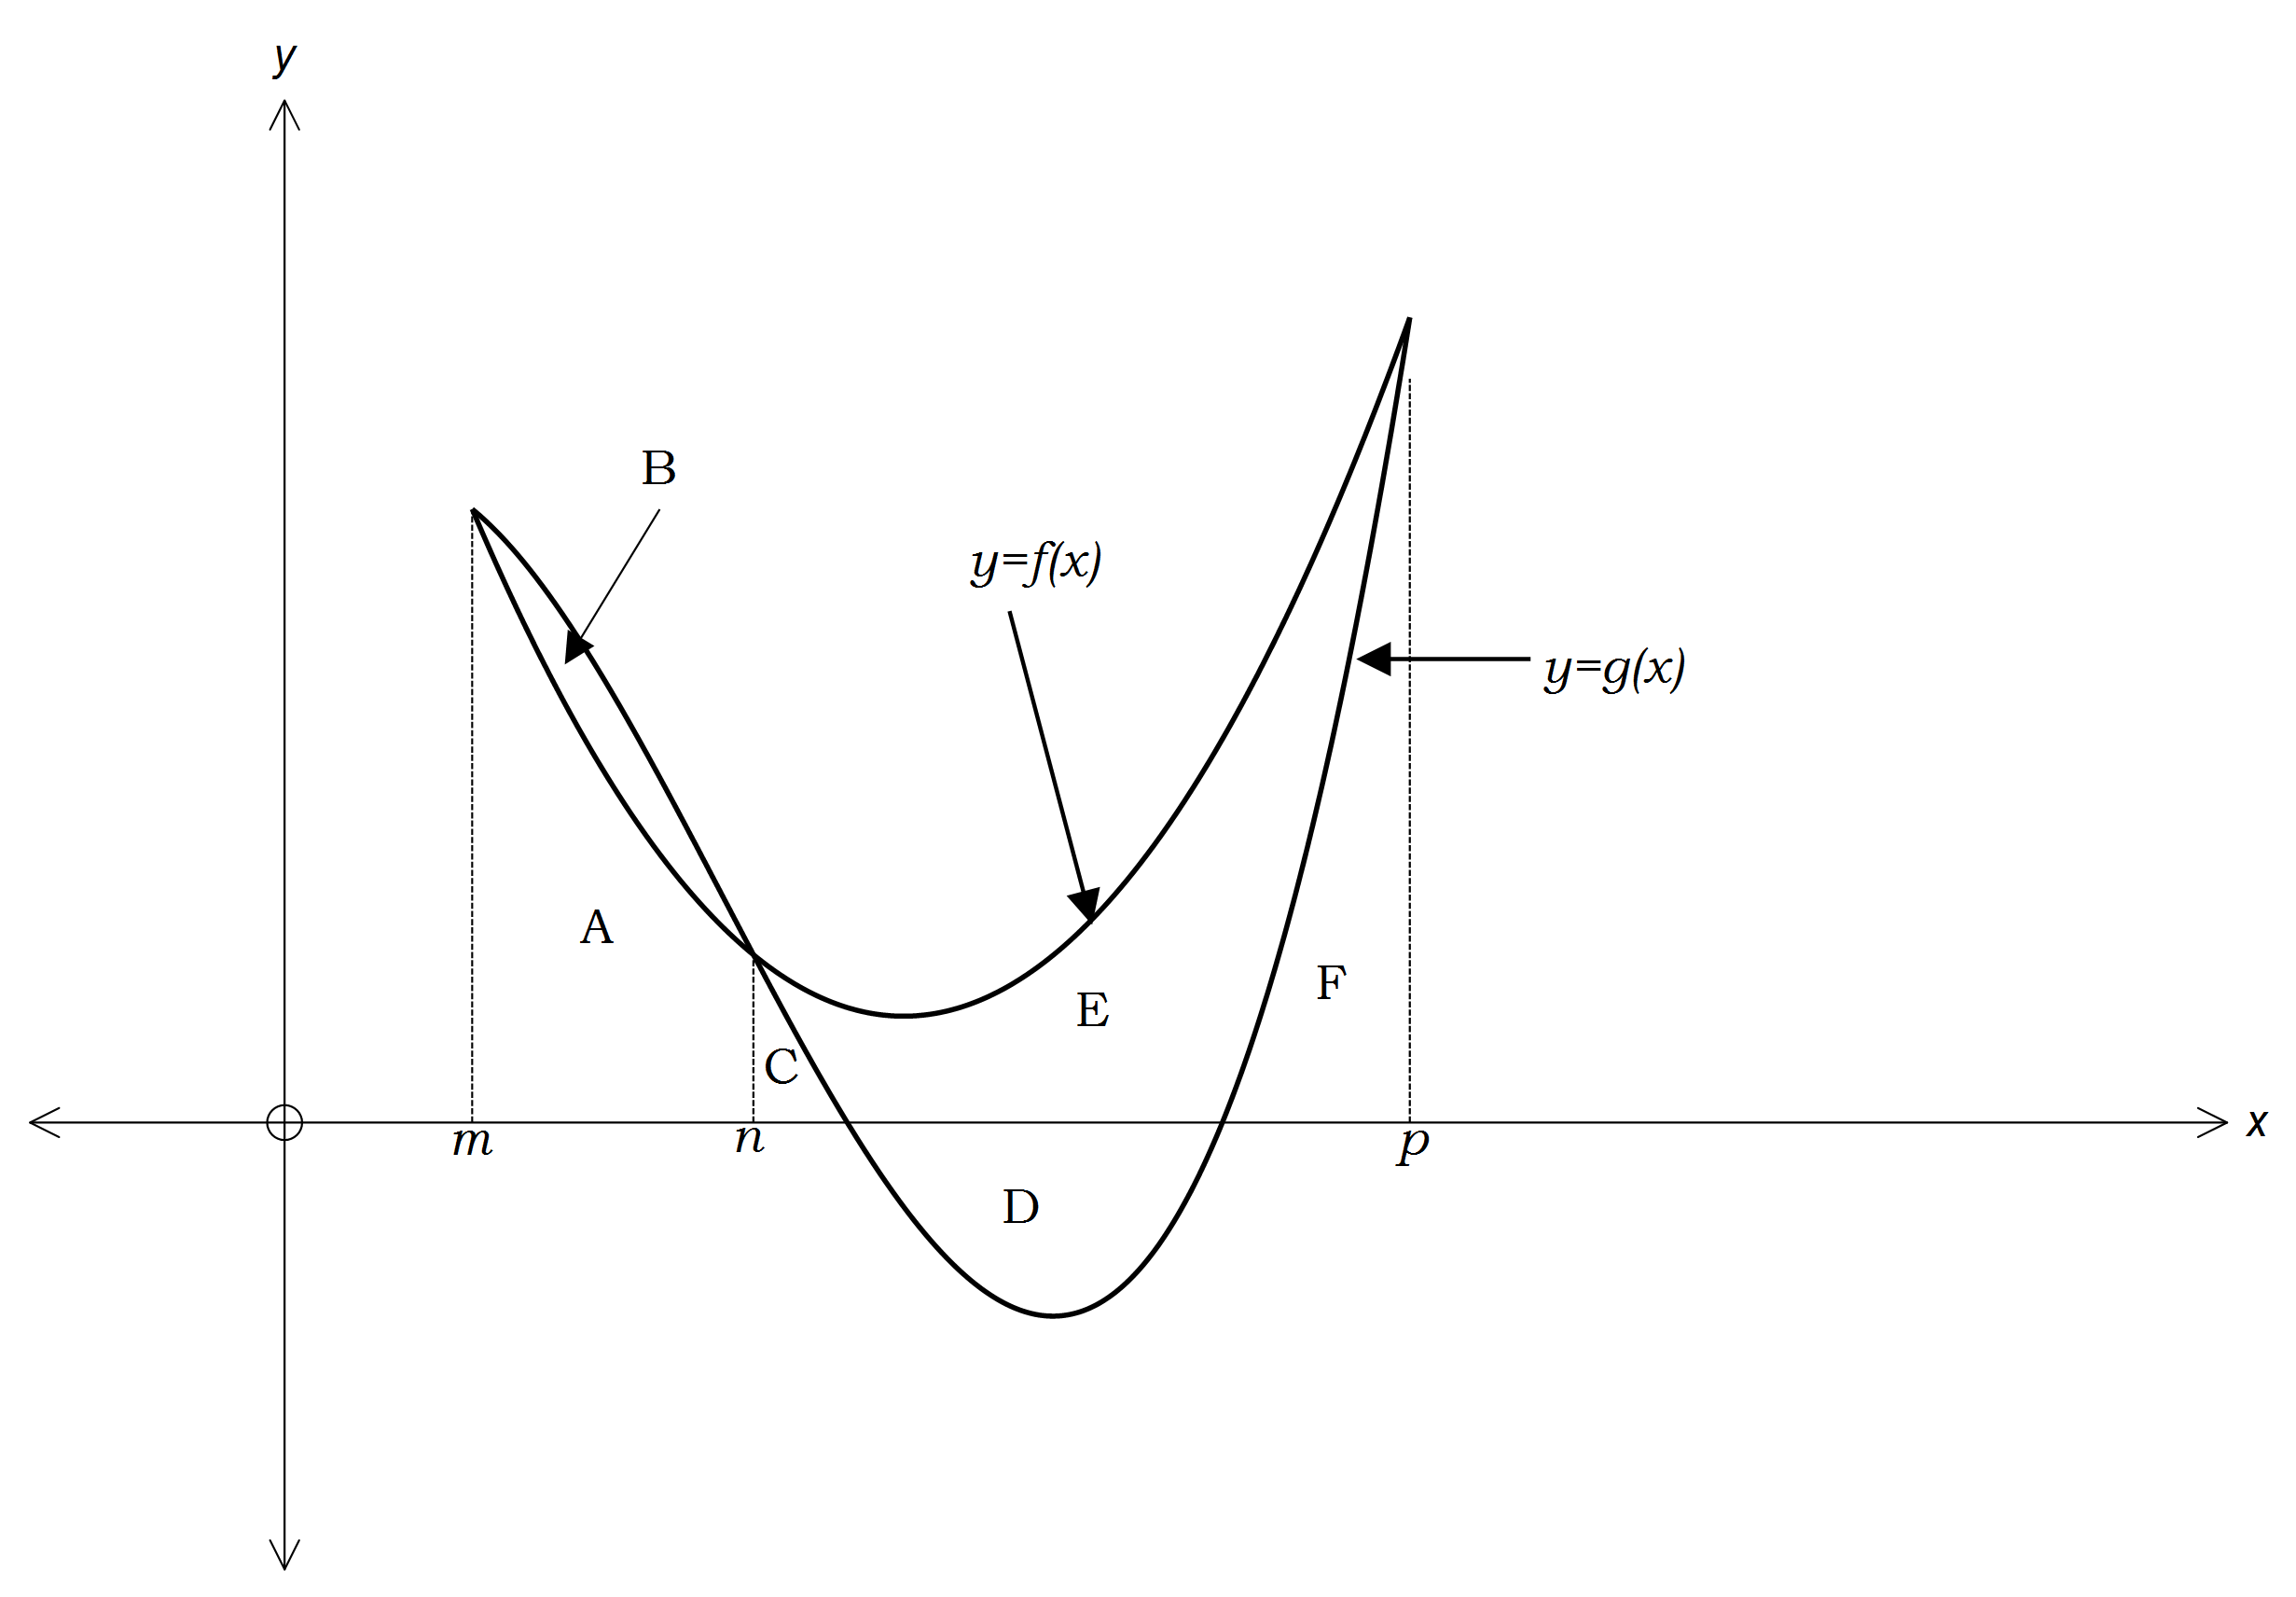area D = 7 units, area E = 17 units and area F = 9 units.

Use this information to determine the following integrals:
(a) $\int_{m}^{n}{f\left(x\right)dx}$ (1 mark)
$=A$
$=14$

(b) $\int_{m}^{n}{f\left(x\right)- g\left(x\right)dx }$ (1 mark)
$=-B$
$=-2$

(c) $\int_{m}^{p}{g\left(x\right)dx}$ (2 marks)
$=A+B+C+F-D$
$=14+2+1+9-7$
$=19$

(d) $\int_{n}^{p}{\left(f\left(x\right)+g\left(x\right)\right) dx}$ (2 marks)
$=C+E+F+C+F-D$
$= 1+17+9+1+9-7$
$=30$
Question 6 (8 marks)

(a) Simplify the following expression: (3 marks)

$\frac{x+5}{x^{2}-5x+4}- \frac{2}{x^{2}+4x-5}+ \frac{7}{x^{2}+x-20}$

$=\frac{x+5}{(x-4)(x-1)}- \frac{2}{(x-1)(x+5)}+ \frac{7}{(x+5)(x-4)}$

$=\frac{(x+5)(x+5)}{(x-4)(x-1)(x+5)}- \frac{2(x-4)}{(x-4)(x-1)(x+5)}+ \frac{7(x-1)}{(x-1)(x+5)(x-4)}$

$=\frac{x^{2}+10x+25}{(x-4)(x-1)(x+5)}- \frac{2x-8}{(x-4)(x-1)(x+5)}+ \frac{7x-7}{(x-1)(x+5)(x-4)}$

$=\frac{x^{2}+10x+25-2x+8+7x-7}{(x-4)(x-1)(x+5)}$

$=\frac{x^{2}+15x+26}{(x-4)(x-1)(x+5)}$

$=\frac{(x+13)(x+2)}{(x-4)(x-1)(x+5)}$

(b) Solve $\frac{3x-1}{x^{2}-1} <1$ (5 marks)
$3x-1 <x^{2}-1$ for $x^{2}-1>0$ or $3x-1>x^{2}-1$ for $x^{2}-1<0$

$0<x^{2}-1-3x+1$ for $x>1, x<-1$ or $0>x^{2}-1-3x+1$for $-1<x<1$

$0<x^{2}-3x$ for $x>1, x<-1$ or $0>x^{2}-3x$ for $-1<x<1$

$0<x(x-3)$ $for x>1, x<-1$ or $0>x(x-3)$ for $-1<x<1$

i.e $x<0$ or $x>3$ $for x>1, x<-1$ or $0<x<3$ for $-1<x<1$

so $x<-1,$ $x>3$ or $0<x<1$
$∴\frac{3x-1}{x^{2}-1} <1$ for $x<-1,$ $0<x<1$, $x>3$
change sign for positive, negative values of $x^{2}-1$
correct domains for positive, negative values of $x^{2}-1$
correct simplification of expression
checks solutions against restricted domains
correct solution

Question 7 (9 marks)

A particle, initially at the origin, moves in such a way that t seconds later, its velocity (in $m/s⁡)$is given by the equation
$v\left(t\right)=at^{2}-bt+c$
(a) Write down expressions for the displacement and acceleration of the particle in terms of t. (2 marks)
Displacement $x\left(t\right)= \frac{at^{3}}{3}- \frac{bt^{2}}{2}+ct+d$ but $d=0$ (initially at origin)
$x\left(t\right)= \frac{at^{3}}{3}- \frac{bt^{2}}{2}+ct$
Acceleration $a\left(t\right)=2at-b$
(b) Given that after 1 second, the particle has a displacement of 2$m$, and is travelling at a velocity of 3$m/s⁡$ with acceleration of $0 m/s^{2}$, write three equations in terms of $a, b$and/or $c$. (3 marks)
$x\left(1\right)= \frac{a}{3}- \frac{b}{2}+c$ i.e $2= \frac{a}{3}- \frac{b}{2}+c$ or $12= 2a- 3b+6c$
$v\left(1\right)=a-b+c$ i.e $3=a-b+c$
$a\left(1\right)=2a-b$ i.e $0=2a-b$
(c) Use a method of elimination to solve the three equations, determining the values of $a, b$and $c$. (4 marks)
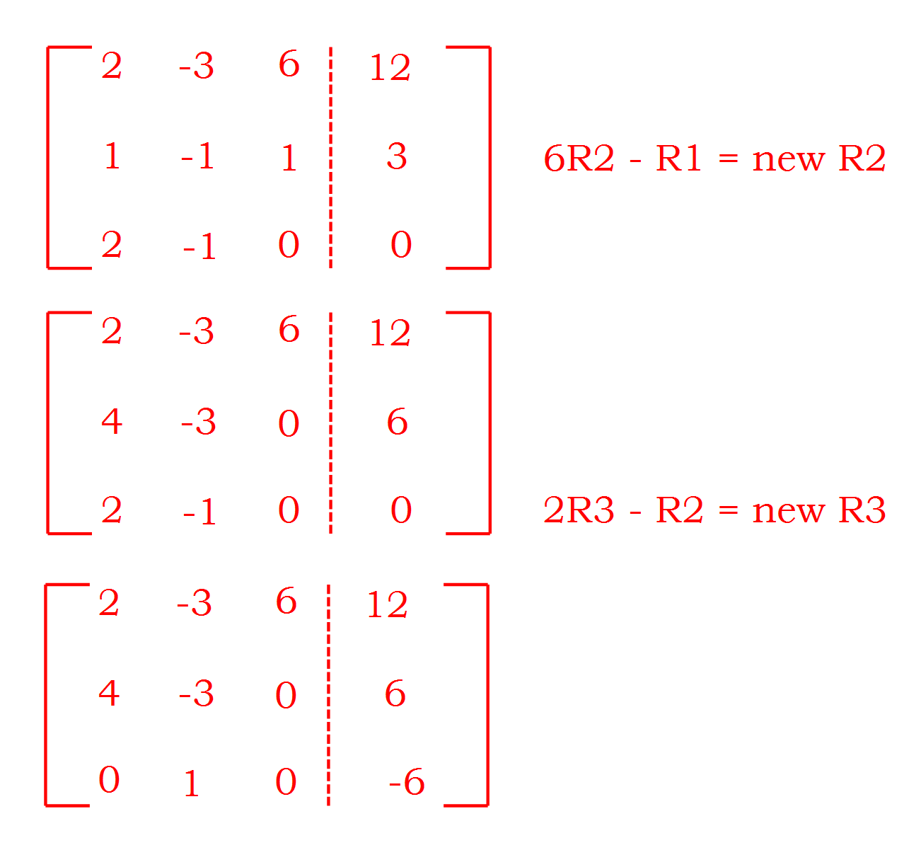 Using an augmented matrix:

Reasoning using a method of elimination
so $b= -6$
$4a-3\left(-6\right)=6$ i.e $4a+18=6$ so $a= -3$
$2\left(-3\right)-3\left(-6\right)+6c=12$
$-6+18+6c=12$ i.e $12+6c=1$ so $c= 0$
$a=-3, b=-6, c=0$
Additional working space
Question number:______

